# Structural Diagram

## High Level Component Diagram

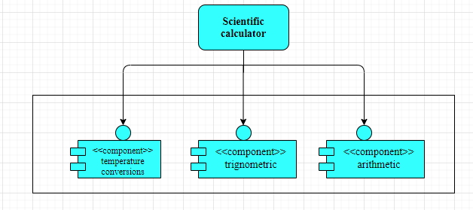

Figure 5 Structural High-Level Component Diagram

## Low Level Deployment Diagram

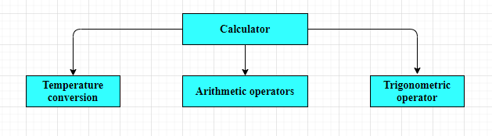

Figure 6 Structural Low-Level Deployment Diagram

## Low Level Class Diagram

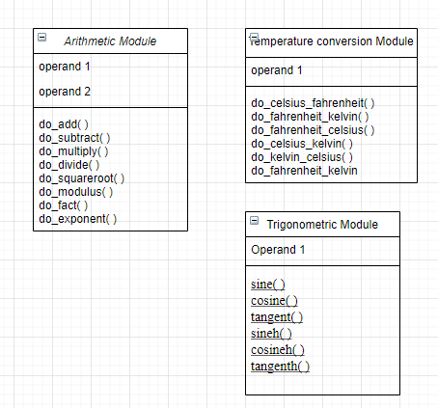

Figure 7 Structural Low-Level Class Diagram